Michael Grinnell Portfolio Design Document

# Project Overview

## Objective

The primary objective of michaelgrinnell.com and dj.michaelgrinnell.com is to establish a professional online presence that showcases Michael Grinnell's diverse skills in software development and DJing and also highlights his specialization and passion for audio programming. These platforms are designed to attract potential clients and employers in the fields of audio software development, gaming audio programming, and related industries.

## Target Audience

Software Development Professionals: Specifically, those in the audio and music technology sector, including companies involved in VST plugin development, game development studios, and independent artists or producers seeking custom audio solutions.

Music and Entertainment Industry Professionals: Including event organizers, music producers, and artists who might benefit from Michael's DJ services and his expertise in sound design and audio programming.

## Unique Value Proposition

Michael Grinnell uniquely combines his programming prowess with a deep understanding of sound design and audio technology. This dual expertise enables him to offer specialized services in creating advanced audio software solutions (like VST plugins) and interactive audio for games, alongside providing professional DJ services. This combination of skills sets him apart in the tech and music industries, offering a comprehensive package of programming and sound design. The website will show that I am good a design, while also showing that I have the technical capabilities to implement.

# Goals

## Demonstrate Design/Development Skills:

* Use modern web design principles.
* Showcase responsive design, ensuring the site works seamlessly on various devices.
* Implement clean, maintainable code, demonstrating best practices in development.
* Animations, minimal design.

## Showcase Programming and Technical Projects:

* Create a dedicated section for your projects.
* Include detailed descriptions, images, and links to live projects or code repositories.
* Blogs detailing my approach and challenges faced in some key projects.

# Considerations:

## User Experience:

* Ensure a seamless and intuitive user experience with responsive design across various devices.
* Implement light and dark mode for user comfort and preference.
* Minimalist design
* Intuitive navigation with a clear hierarchy
* Responsive design for a seamless experience across devices
* Touch friendly interface elements
* Translation to multiple languages
* Focus on creating a user-friendly interface, with easy navigation and clear calls-to-action.
* Pay attention to details like load times, mobile responsiveness, and accessibility.

## Content Management

* **API Integration**: WordPress REST API for content fetching
* **Frontend**: React for dynamic content rendering
* **Backend**: WordPress as a headless CMS for content management
* Regularly update your portfolio with new projects and blog posts to keep the content fresh and relevant.

## Performance and Optimization

* Keep an eye on the website's performance, especially with features like animated backgrounds. Use tools like Google Lighthouse for performance insights.
* Optimize images and assets to ensure fast loading times.

## SEO and Analytics

* Implement SEO best practices to improve the visibility of your site.
* Integrate analytics to track visitor behaviour and gain insights.

## Security

* Ensure robust security measures for both the main domain and subdomain

# Additional Objectives

## Home Server for Hosting:

* Configure your home server for web hosting.
* Ensure you have a reliable internet connection and consider uptime, security, and maintenance aspects.

## Secondary Site for DJ Services (dj.michaelgrinnell.com):

* Utilize the same backend and styling for brand consistency.
* Ensure both sites are interlinked for seamless navigation.
* The DJ site should focus on your music, gigs, mixes, and production work.

# Additional Features

## Animated Background on the Homepage

* Implement a subtle, performance-optimized animation that doesn’t distract from the content.

## Dark/Light Mode Detection and Setting

* Use CSS and React context for managing theme.
* Detect user’s system preferences for initial theme setting.

## Filtering Mechanism for Projects and Blog Posts

* Implement filters to allow users to search by tag, category, date, etc.
* Ensure the filtering UI is intuitive and integrates well with the overall design of the site.

## Dynamic Navigation

* If user on homepage, scroll to section, otherwise navigate to relevant page.
* Contact form opens in a model

## Cross-Linking Between Sites

* Make sure the link to your DJ site is prominent on your main site and vice versa.
* Use this as an opportunity to showcase the diversity of your skills and interests.

# UI Elements

## Main Navbar

## Contact Dialogue

This will be a model/dialogue element that can be re-used throughout the site so I can avoid creating multiple contact forms. Ensure to include icon links to relevant places such as LinkedIn or Github other professional social media profiles.

<https://www.youtube.com/watch?v=ywtkJkxJsdg&t=3s&ab_channel=WebDevSimplified>

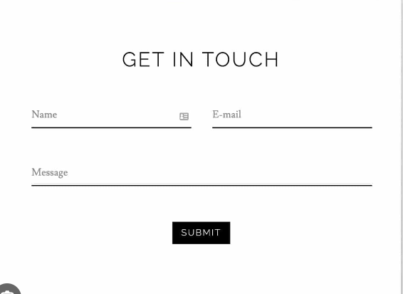

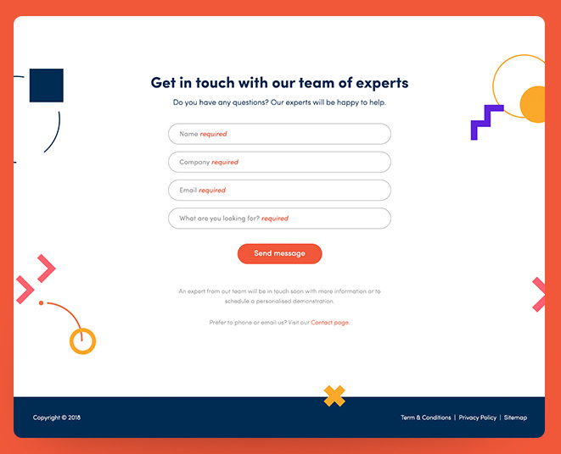

## **Tags Search**

Search feature to implement for projects and blogs  
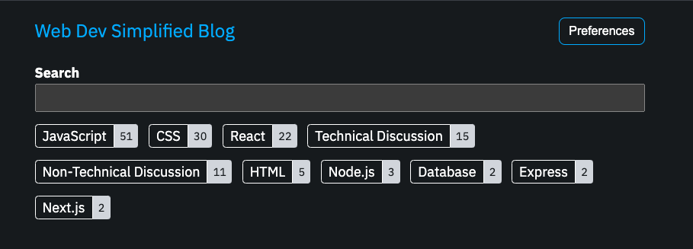

## **Footer**:

The footer can reiterate your contact information, include legal disclaimers, and offer quick links to other sections of your portfolio or external profiles.

# UI Design

### Light colour scheme

* **Primary colour**: Muted Blue/Teal
* **Secondary colours**: Light Grey, Pastel Blue
* **Background colour**: White or Light Grey

### Dark Colour Scheme

* **Primary colour**: Muted Blue/Teal
* **Secondary colours**: Light Grey, Pastel Blue
* **Background colour**: White or Light Grey

### Typography

* **Main Font**: Roboto or Open Sans
* **Headings Font**: Same as main or a complementary font
* **Font Sizes**: Readable body text with varied sizes for headings

### Layout and Spacing

* Generous use of whitespace
* Grid layout for content organization
* Consistent margins and padding

### User Interface Elements

* **Navigation Bar**: Simple and clear
* **Buttons**: Flat design with hover effect
* **Icons**: Line based, minimalistic

# Main domain michaelgrinnell.com

## Home Page

For the home page the goal is to immediately capture the visitor's attention and guide them to key information about my skills and work.

### Hero Section:

1. Headline: A clear, compelling statement about who you are (e.g., "Innovative Software Engineer Specializing in Game and Audio Programming").
2. Subhead line: A brief sentence or two that expands on your headline, adding context or specifics about your expertise.
3. Call to Action (CTA): A button or link inviting visitors to learn more about you, view your projects, or contact you.

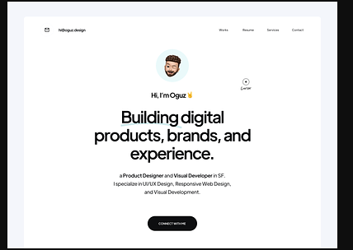



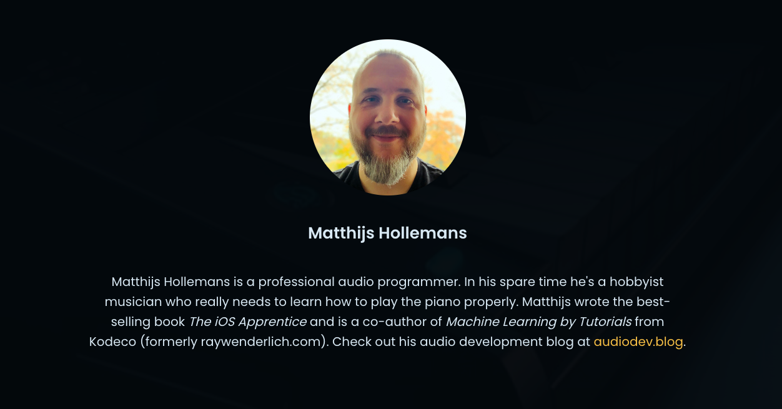

### About Me:

A concise introduction that includes, professional title, areas of specialization, and a summary of my background and what drives you as a software engineer. This section should set the stage for the rest of the content. Add in a button that opens a contact form model.

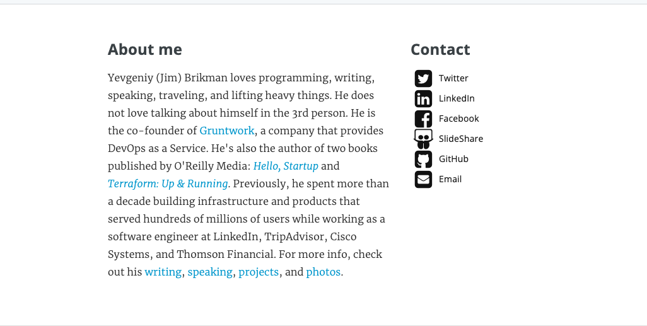

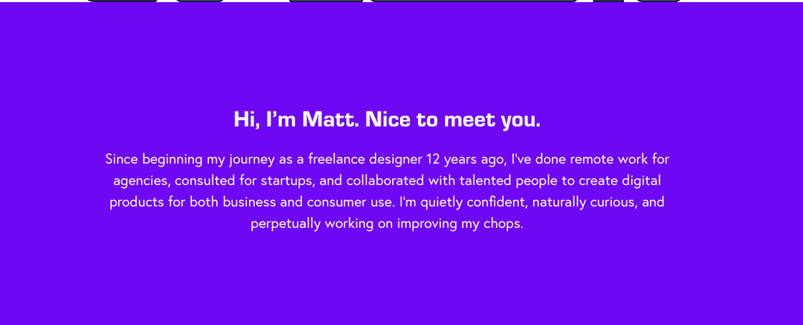

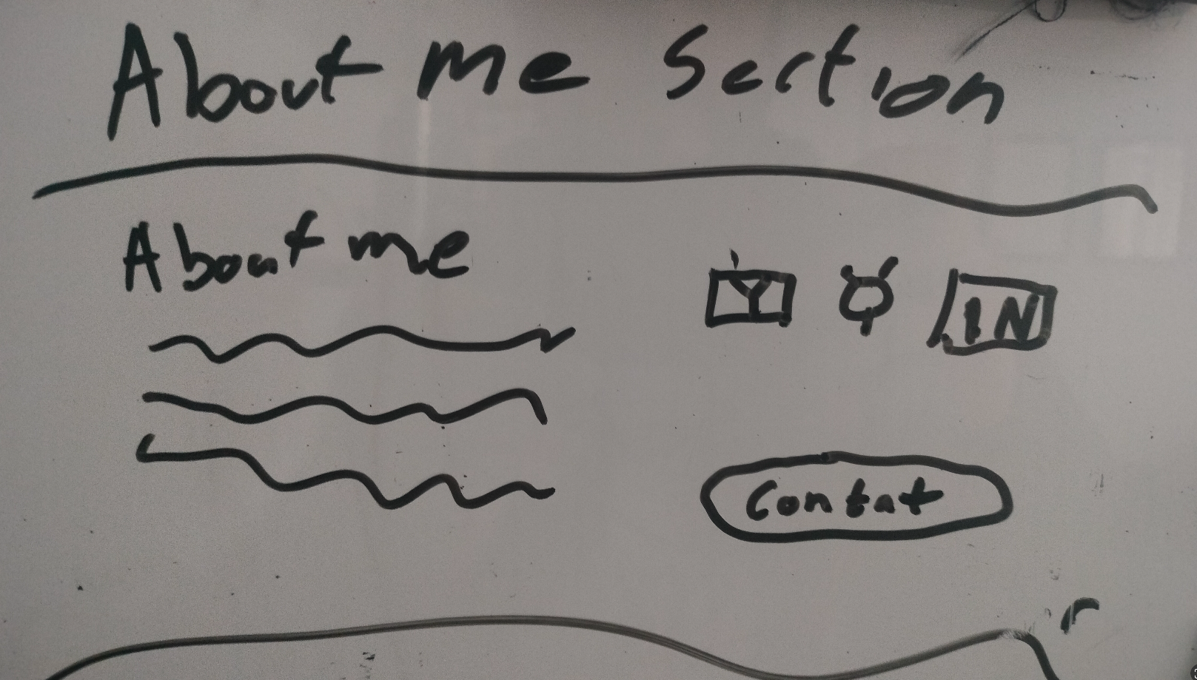

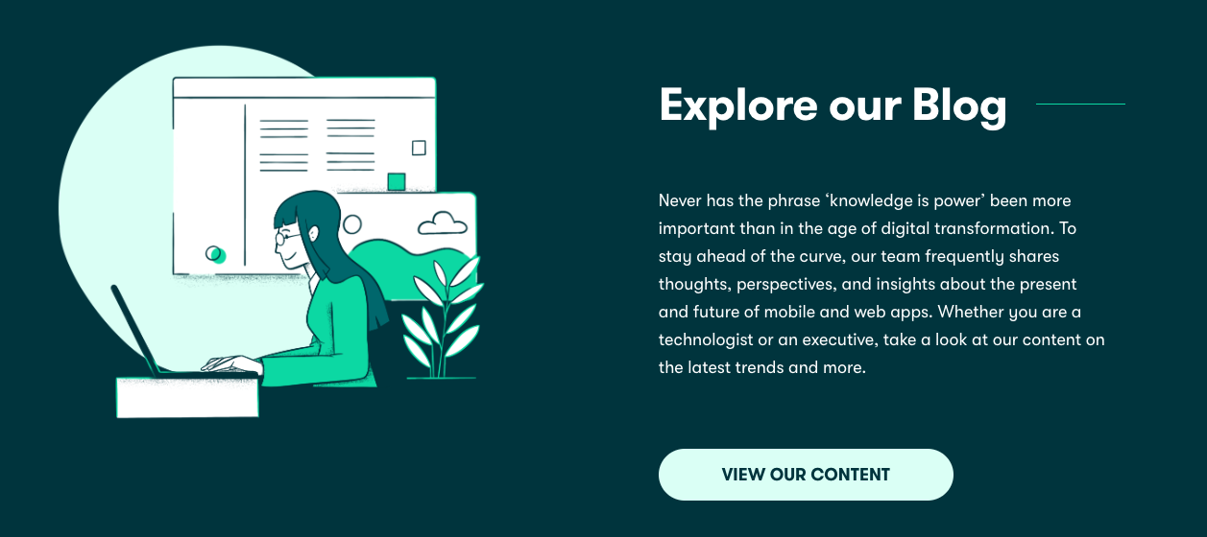

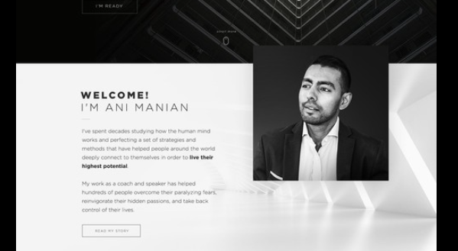  
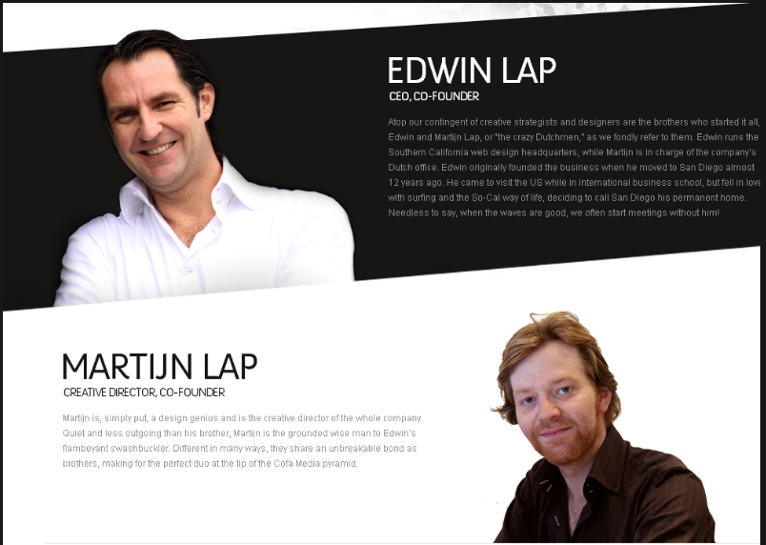

### Skills Snapshot

A visually engaging section highlighting key technical skills, such as programming languages, frameworks, tools, and systems. Icons or progress bars can visually represent your proficiency levels or areas of expertise.

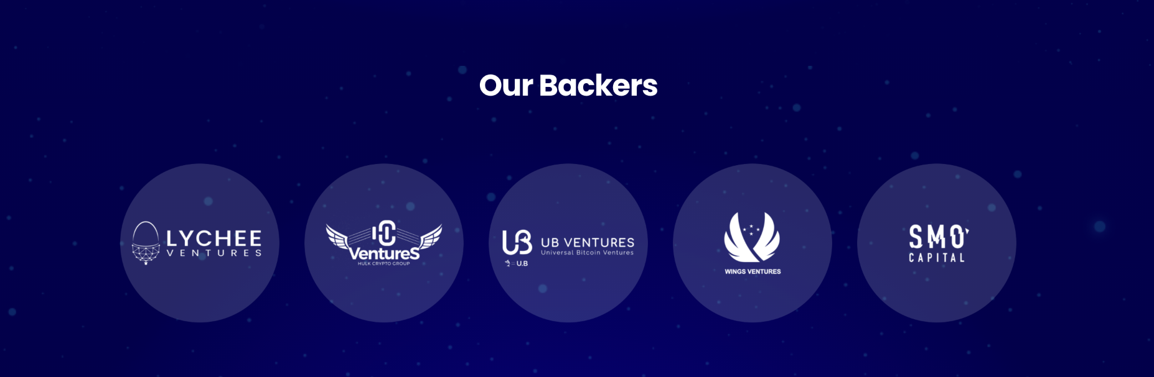

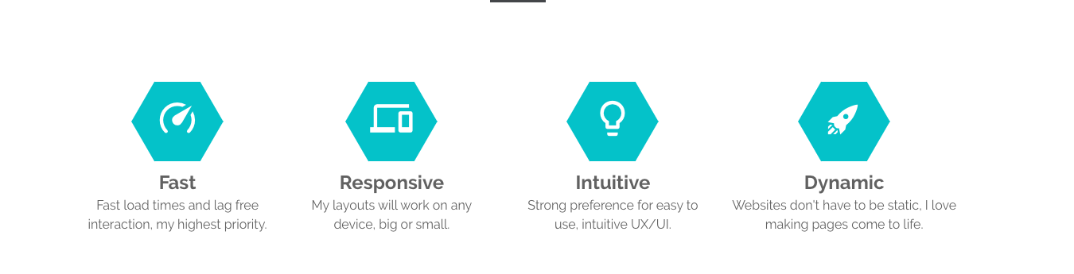

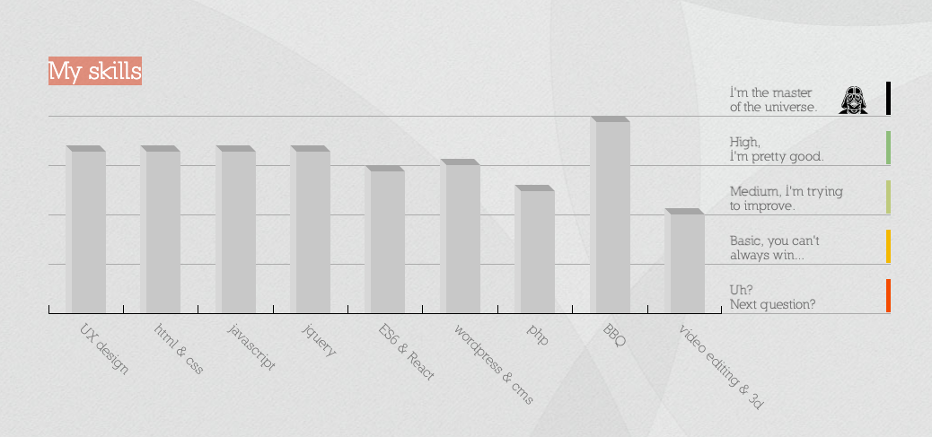

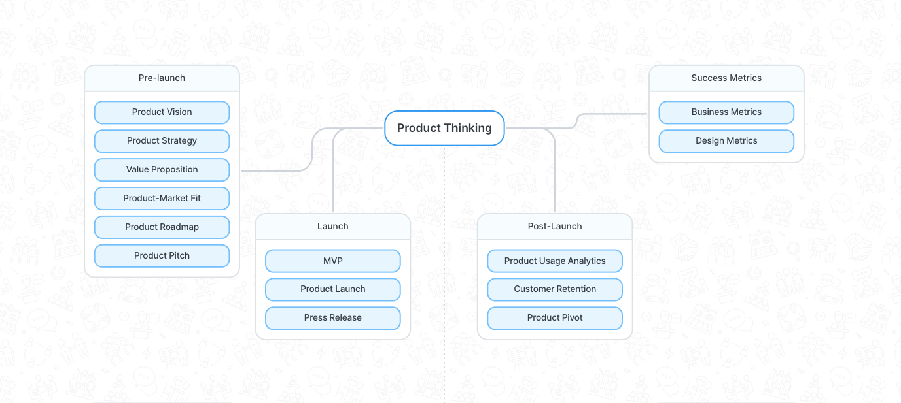

### Featured Projects / Blog Articles

Showcase a few select projects that best represent my work and achievements. Include a mix that covers different technologies and areas of interest. For each project, provide a brief description, the technology stack used, and outcomes. Links to case studies or GitHub repositories are highly beneficial. A snippet from your latest articles or blog posts can demonstrate your expertise and engagement with the software engineering community.

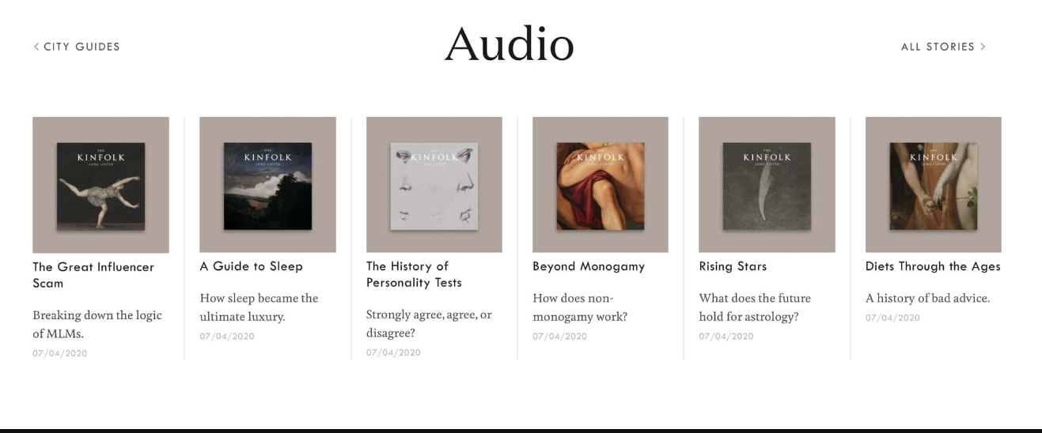

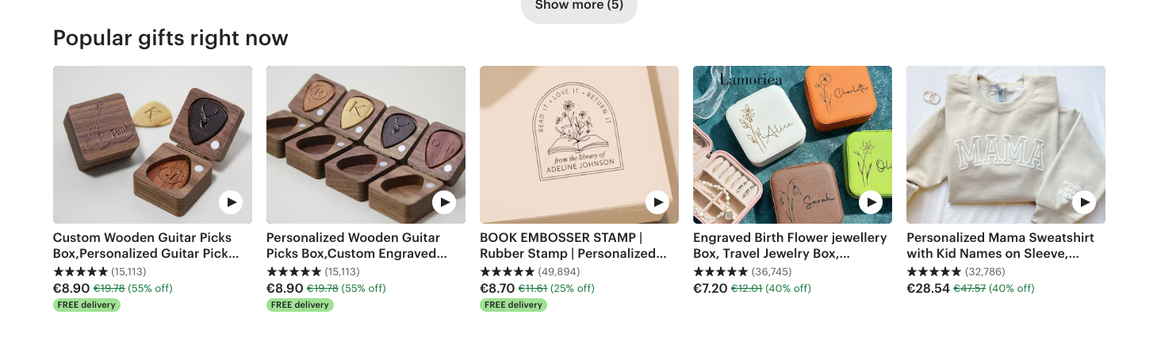

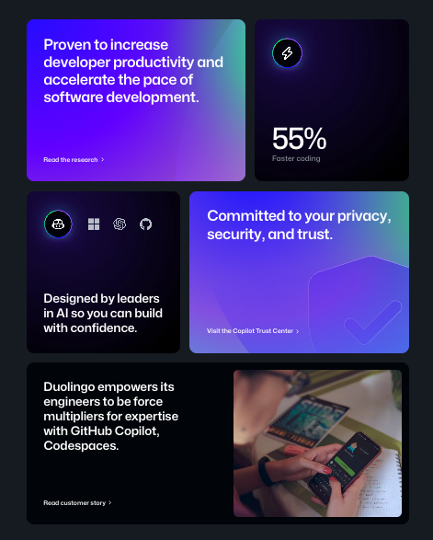

### Experience Overview

A brief section summarizing your professional experience, emphasizing roles or projects that showcase your skills and contributions. You might list your current or most impactful role here, inviting visitors to explore your detailed resume or LinkedIn profile for more information.

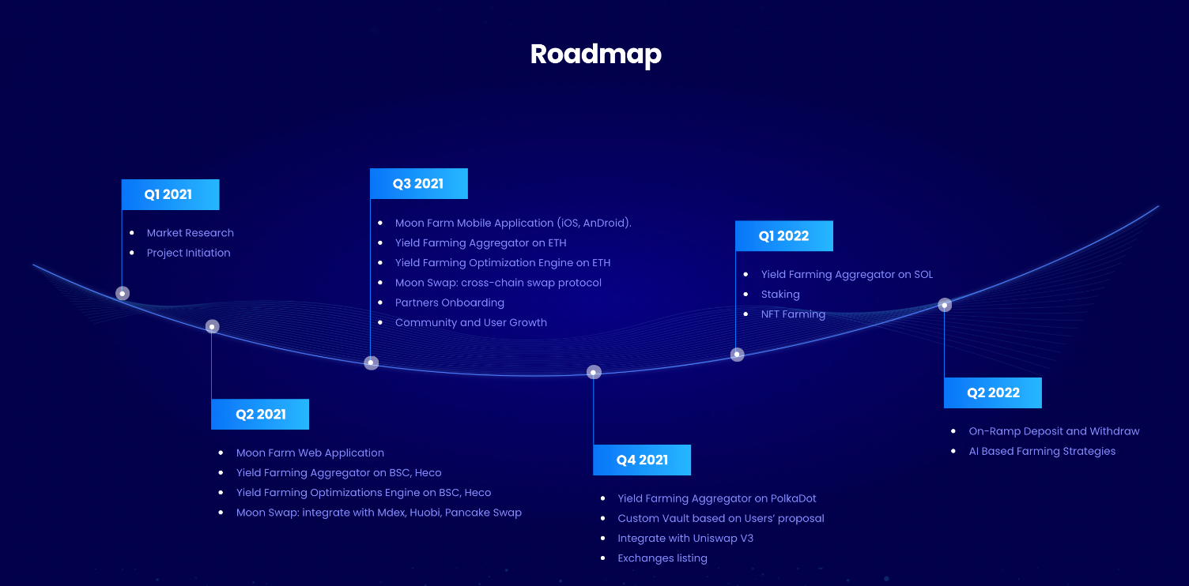

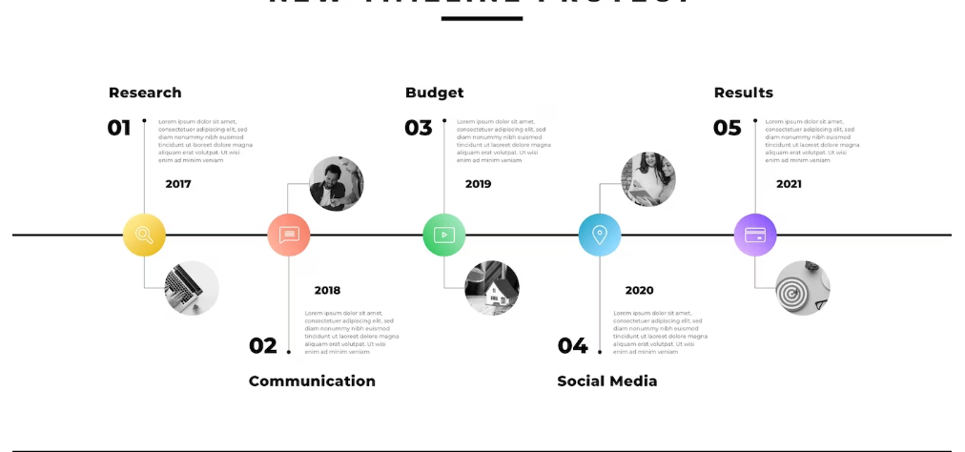

## Portfolio/Blog

* Clicking on Blog or portfolio will bring user to the same page with relevant filter applied. Blog posts or projects, *“/posts?type=projects”, “/posts?type=article”*
* Overview of Michael's projects and skills
* Filterable portfolio gallery (Web Development, C++, Hardware Projects, etc.)
* Articles, tutorials (e.g., home server setup)
* Subscription option

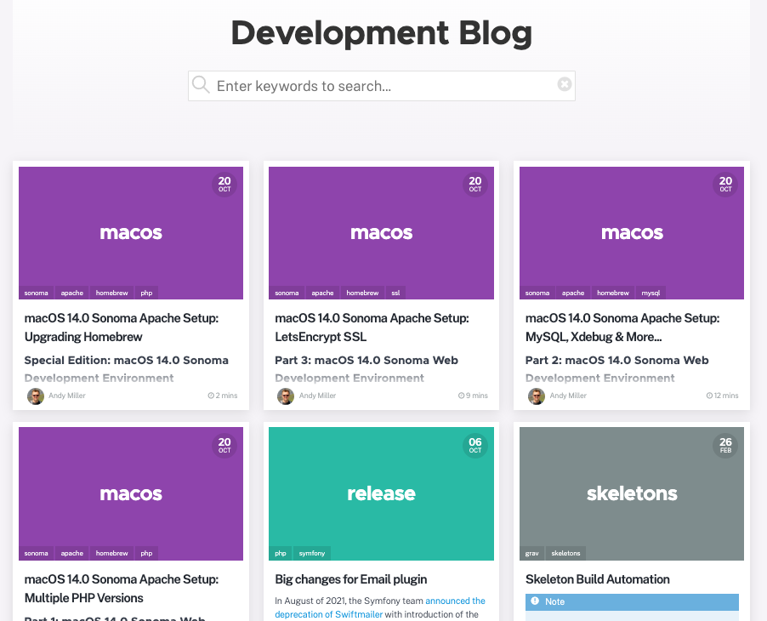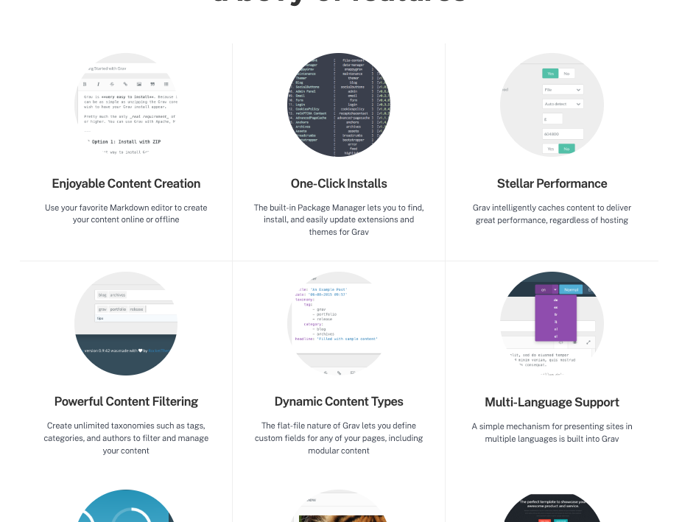

## Blog/Article Page

* Individual project details upon selection
* Estimated Read time
* Related Articles
* Share option

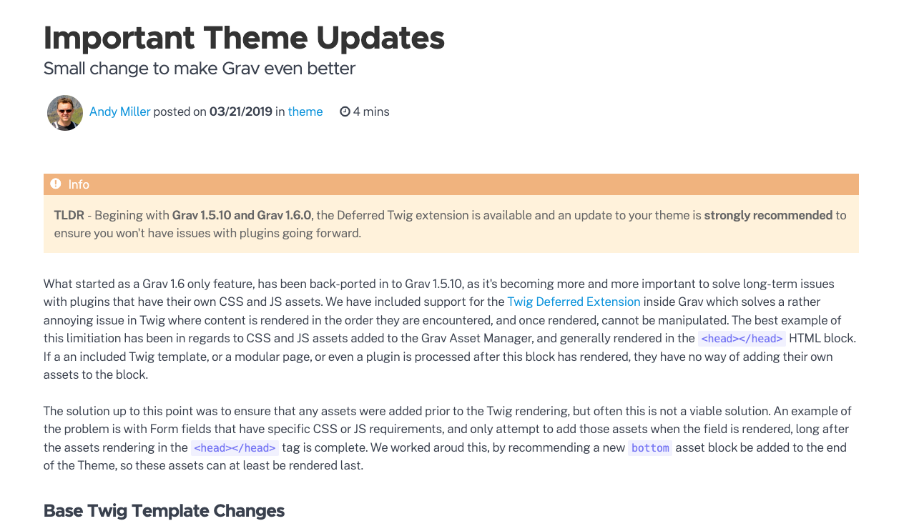

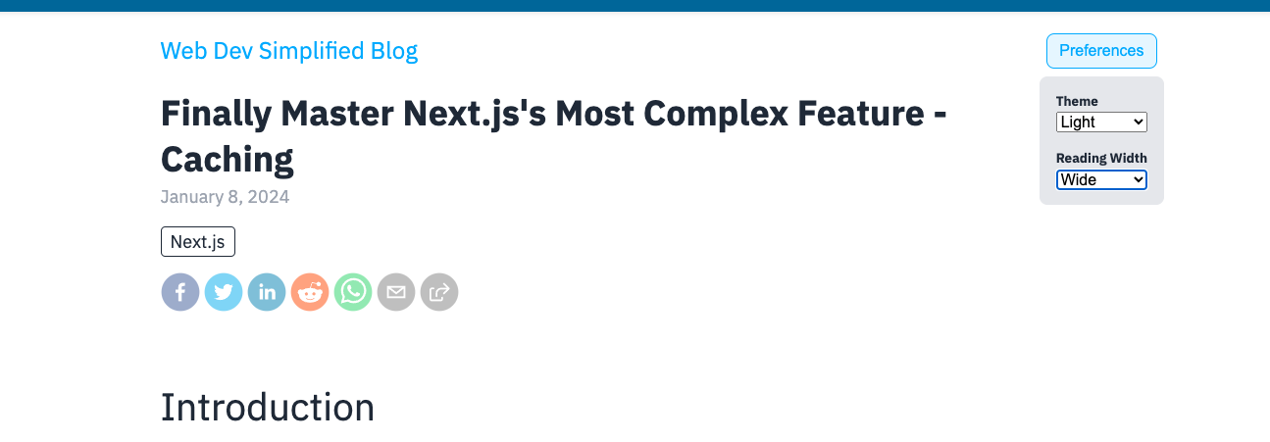

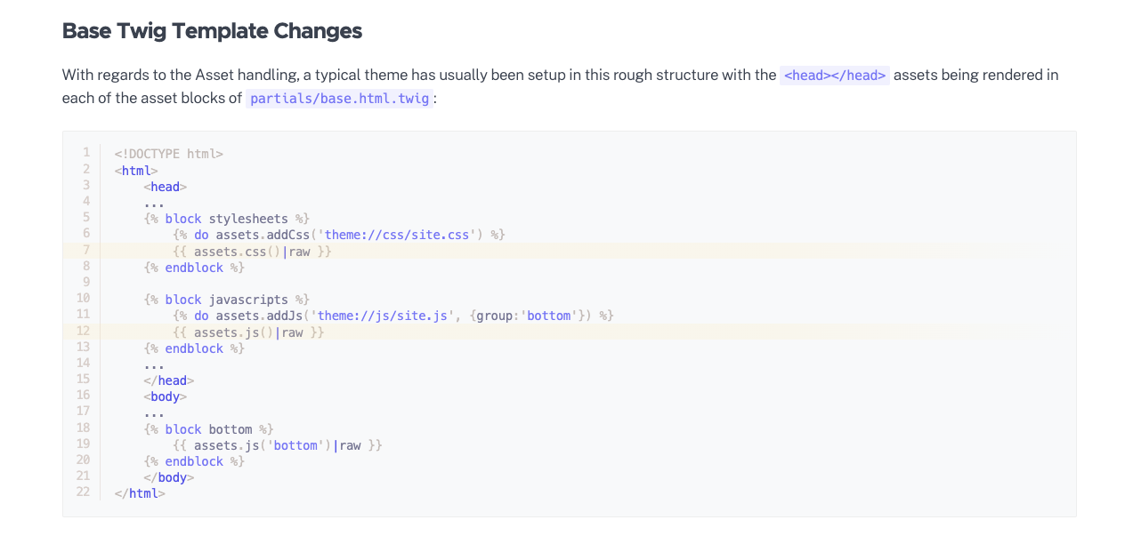

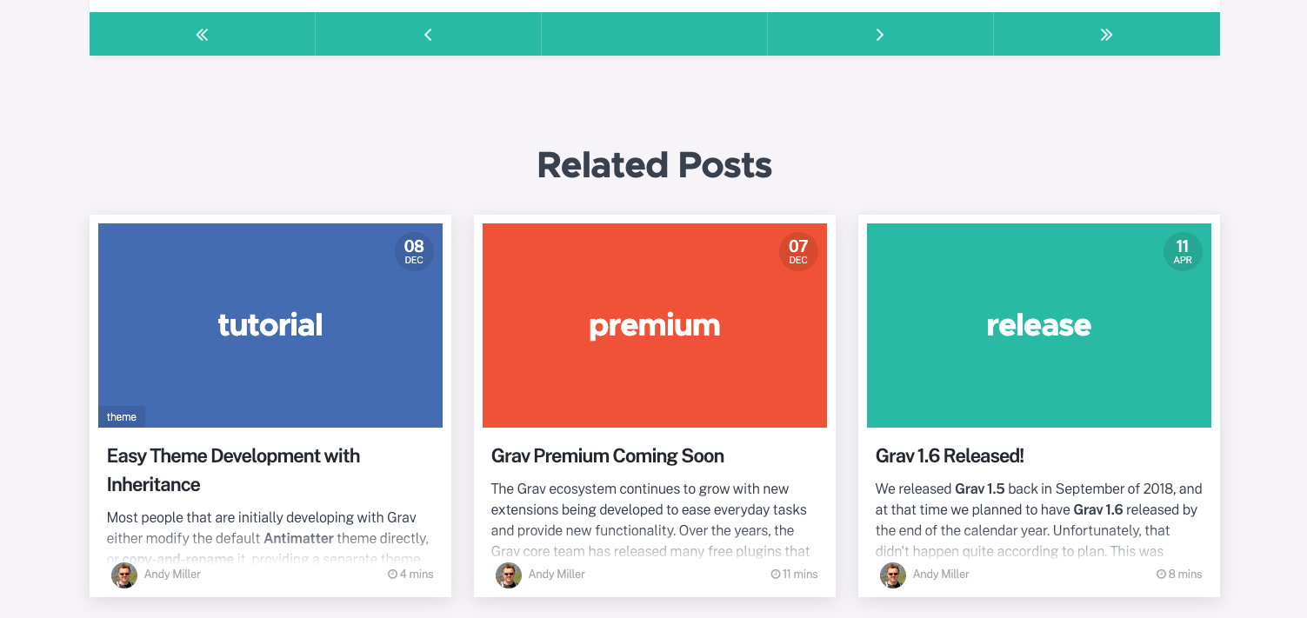

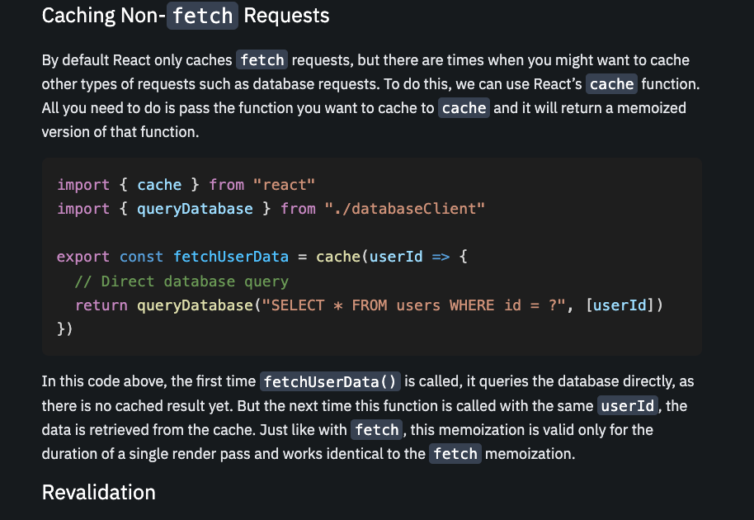

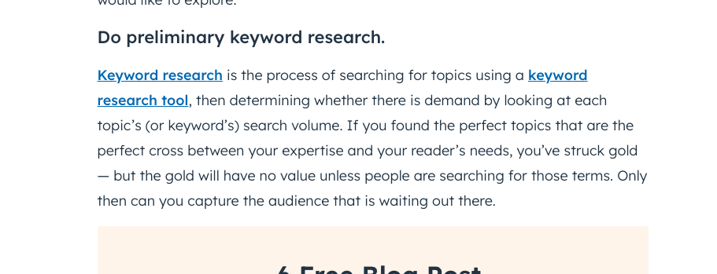

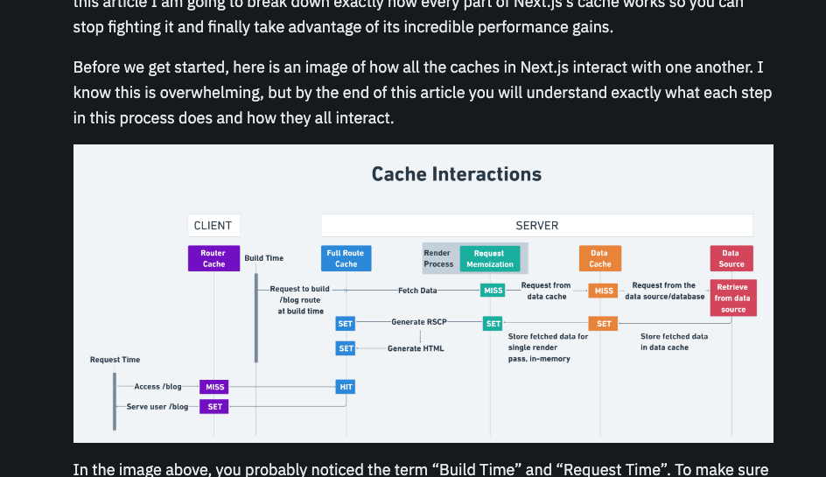

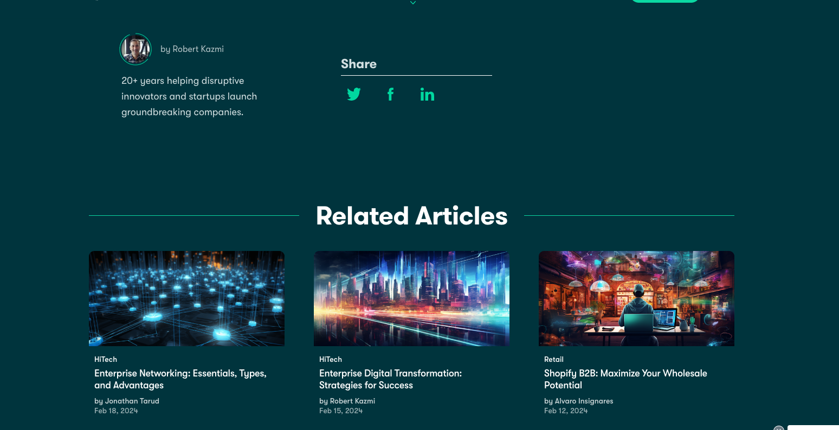

## About Page

* Professional bio and background
* More about my personality and hobbies, as the professional stuff is already on the site, if someone comes here, they are trying to find out a bit more about me.
* Skills and expertise showcase
* Contact button
* Links to other places

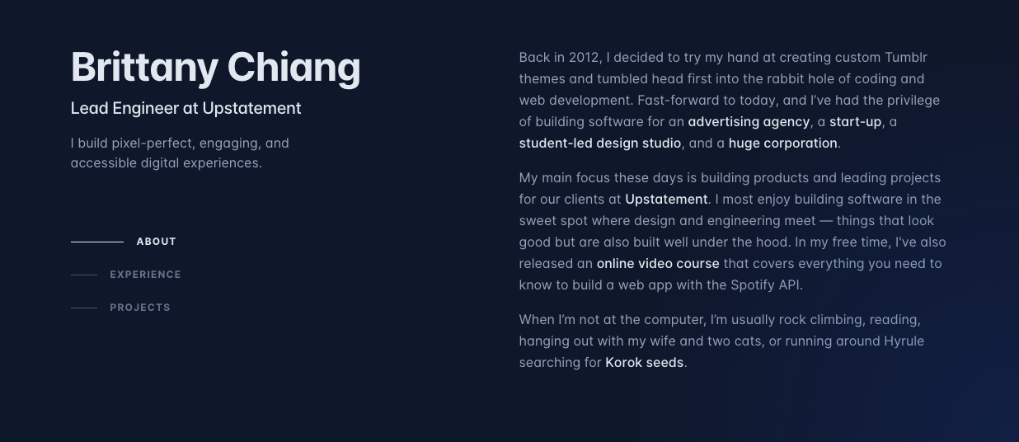

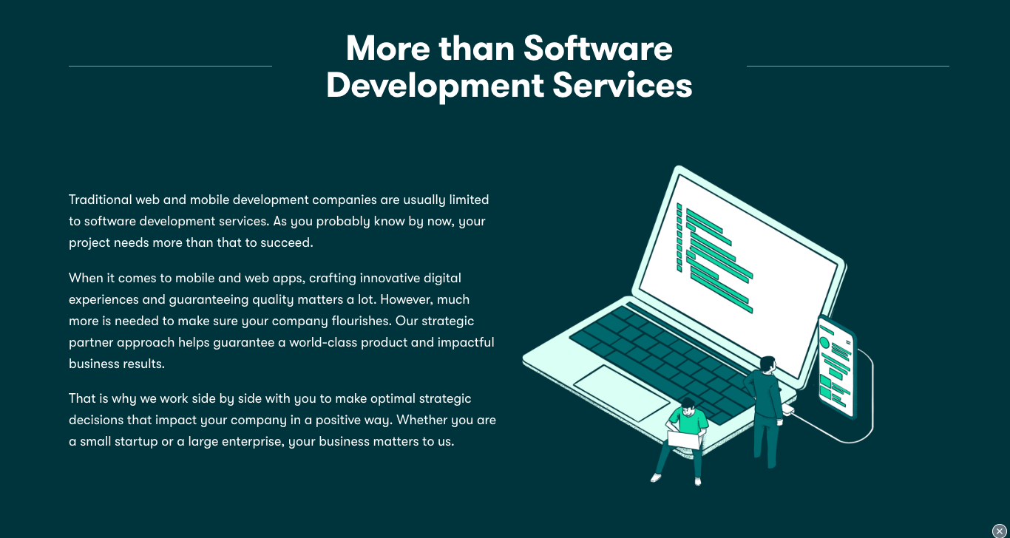

# Sub domain: dj.michaelgrinnell.com

## DJ Home Page

* Introduction to DJ persona
* Overview of DJ services and navigation to mixes, produced songs, and booking

## Mixes and Songs

* Gallery of DJ mixes and produced tracks
* Options to listen, download, or share

## DJ Services

* Types of events catered to
* Booking information

## DJ Contact Page

* Booking inquiry form
* Links to DJ focused social media and music platforms

# Implementation

## Development

1. Project Management
   1. Design Document
   2. Task Planning
   3. Repository Management
2. Development
   1. Build Front end UI
      1. Create templates & components
      2. Use placeholders for content
   2. Configure WordPress instance
   3. Connect front to backend
      1. Postman collection
   4. Create content
3. Updates
   1. Apply any updates to tools and frameworks used

## Testing

* Cross browser and device testing
* Performance optimization (load times, image optimization)
* Deployment on a suitable hosting platform

## Deployment

* Point Domain to correct address
* Configure local server

## Maintenance

* Regular content updates via WordPress
* Periodic checks for security updates and performance optimization
* Link with GitHub for ease of deployments